Sample Latent Profile Analysis Audit
This synthetic audit compares covariance assumptions, model stability, and two ways to estimate differences in persistence. The generating model used three overlapping profiles with correlated indicators. The fitted models may recover a different structure.

Analysis sample and missingness
Of 600 simulated cases, 380 had all six indicators. The achieved missing-cell rate was 8.22%. The mask depends on observed stress by design. In a diagnostic regression, the estimated log odds of any missing indicator changed by 0.899 per unit of stress. Observed associations assess plausibility. Neither descriptive checks nor Little’s test alone establish MCAR or MAR. Complete cases provide a common comparison sample here. Deletion under MAR can change the target population and estimates.

Model fit
BIC, AIC, SABIC and classification-based ICL use the lower-is-better convention. The one-component covariance aliases are shown under both grid labels. BLRT was omitted. Bootstrap LRT interpretation depends on sample size and a mixture reference distribution.
Structure | K | LogLik | AIC | BIC
EEI | 1 | -3671.9414001881 | 7367.8828003761 | 7415.1648554088
EEI | 2 | -3345.7967597969 | 6729.5935195939 | 6804.4567733956
EEI | 3 | -3261.6618444566 | 6575.3236889131 | 6677.7681414839
EEI | 4 | -3218.1942882966 | 6502.3885765931 | 6632.4142279329
EEI | 5 | -3170.3225449758 | 6420.6450899515 | 6578.2519400604
EEI | 6 | -3151.150498259 | 6396.300996518 | 6581.4890453958
VVI | 1 | -3671.9414001881 | 7367.8828003761 | 7415.1648554088
VVI | 2 | -3330.9685858947 | 6711.9371717894 | 6810.4414531074
VVI | 3 | -3245.0267007506 | 6566.0534015013 | 6715.7799091047
VVI | 4 | -3192.3066036243 | 6486.6132072485 | 6687.5619411373
VVI | 5 | -3154.4826687829 | 6436.9653375658 | 6689.1362977399
VVI | 6 | -3129.0243069576 | 6412.0486139151 | 6715.4418003746
EEE | 1 | -3128.9856402749 | 6311.9712805498 | 6418.3559043732
EEE | 2 | -3112.2597795494 | 6292.5195590988 | 6426.4853816913
EEE | 3 | -3092.1891265516 | 6266.3782531032 | 6427.9252744647
EEE | 4 | -3076.420910891 | 6248.841821782 | 6437.9700419126
EEE | 5 | -3068.8115375708 | 6247.6230751415 | 6464.3324940412
EEE | 6 | -3061.6904981259 | 6247.3809962518 | 6491.6716139204
VVV | 1 | -3128.9856402749 | 6311.9712805498 | 6418.3559043732
VVV | 2 | -3075.8786080451 | 6261.7572160902 | 6478.4666349898
VVV | 3 | -3043.0770243884 | 6252.1540487768 | 6579.1882627526
VVV | 4 | -3014.6093935783 | 6251.2187871566 | 6688.5777962086
VVV | 5 | -2963.2025748559 | 6204.4051497118 | 6752.0889538399
VVV | 6 | -2942.0744084375 | 6218.148816875 | 6876.1574160793

Additional information criteria
Structure | K | SABIC | ICL | BLRT p
EEI | 1 | 7377.0912017152 | 7415.1648554088 | Not computed
EEI | 2 | 6744.1734883808 | 6844.9572038483 | Not computed
EEI | 3 | 6595.2752251479 | 6768.6587425232 | Not computed
EEI | 4 | 6527.7116802757 | 6730.2800933335 | Not computed
EEI | 5 | 6451.3397610819 | 6703.6765367096 | Not computed
EEI | 6 | 6432.3672350961 | 6717.0052141841 | Not computed
VVI | 1 | 7377.0912017152 | 7415.1648554088 | Not computed
VVI | 2 | 6731.1213412458 | 6850.8157952359 | Not computed
VVI | 3 | 6595.2133390751 | 6793.8318202846 | Not computed
VVI | 4 | 6525.7489129397 | 6774.9165047132 | Not computed
VVI | 5 | 6486.0768113743 | 6796.7538062062 | Not computed
VVI | 6 | 6471.135855841 | 6826.5474763666 | Not computed
EEE | 1 | 6332.6901835627 | 6418.3559043732 | Not computed
EEE | 2 | 6318.6100295596 | 6504.4235887673 | Not computed
EEE | 3 | 6297.8402910118 | 6560.4384781843 | Not computed
EEE | 4 | 6285.6754271385 | 6560.6638808734 | Not computed
EEE | 5 | 6289.8282479458 | 6605.4625309117 | Not computed
EEE | 6 | 6294.9577365038 | 6670.3061411841 | Not computed
VVV | 1 | 6332.6901835627 | 6418.3559043732 | Not computed
VVV | 2 | 6303.9623888944 | 6554.0040769165 | Not computed
VVV | 3 | 6315.8454913723 | 6690.3971694429 | Not computed
VVV | 4 | 6336.3964995433 | 6747.770119415 | Not computed
VVV | 5 | 6311.0691318898 | 6837.5013023752 | Not computed
VVV | 6 | 6346.2990688441 | 6947.246740102 | Not computed

Classification and stability
Entropy of 0.80 and minimum AvePP of 0.70 are contextual guides to classification precision. Entropy is undefined for one profile. Class size is based on modal assignment. Each multi-profile fit starts from a hierarchical initialization and eight seeded random-center partitions. A repeat is a converged solution within 0.001 log likelihood units of the best converged fit. Repeated likelihoods do not establish a global optimum.
Covariance | K | Entropy | Min AvePP | Min class % | Min class n
EEI | 1 | Not computed | 1 | 100 | 380
EEI | 2 | 0.84336536128 | 0.93664481555 | 40 | 152
EEI | 3 | 0.78604750633 | 0.87281755327 | 20.5263157895 | 78
EEI | 4 | 0.80585193631 | 0.81385626042 | 12.1052631579 | 46
EEI | 5 | 0.79272222469 | 0.83128616323 | 12.1052631579 | 46
EEI | 6 | 0.79286316318 | 0.82770953784 | 7.1052631579 | 27
VVI | 1 | Not computed | 1 | 100 | 380
VVI | 2 | 0.84975606304 | 0.93933922402 | 39.2105263158 | 149
VVI | 3 | 0.81205548109 | 0.89713166672 | 18.6842105263 | 71
VVI | 4 | 0.81719562481 | 0.86533643929 | 11.3157894737 | 43
VVI | 5 | 0.80880583222 | 0.84634823355 | 11.0526315789 | 42
VVI | 6 | 0.82344021898 | 0.85419838964 | 5.7894736842 | 22
EEE | 1 | Not computed | 1 | 100 | 380
EEE | 2 | 0.70134017873 | 0.85389341063 | 27.3684210526 | 104
EEE | 3 | 0.66951151896 | 0.83040589665 | 28.1578947368 | 107
EEE | 4 | 0.75168272041 | 0.84735855793 | 11.0526315789 | 42
EEE | 5 | 0.75475829683 | 0.74327904024 | 8.4210526316 | 32
EEE | 6 | 0.72569445157 | 0.7228740252 | 9.4736842105 | 36
VVV | 1 | Not computed | 1 | 100 | 380
VVV | 2 | 0.70915176812 | 0.90356905043 | 42.1052631579 | 160
VVV | 3 | 0.72411254992 | 0.76190091094 | 22.6315789474 | 86
VVV | 4 | 0.88086935488 | 0.88041638589 | 4.2105263158 | 16
VVV | 5 | 0.85336117088 | 0.81979071088 | 6.8421052632 | 26
VVV | 6 | 0.89095471982 | 0.79497897342 | 4.7368421053 | 18

Start replication and flags
Model | K | Starts | OK | Repeats | Flags
EEI | 1 | 1 | 1 | 1 | Clear
EEI | 2 | 9 | 9 | 9 | Clear
EEI | 3 | 9 | 9 | 9 | Clear
EEI | 4 | 9 | 9 | 3 | Clear
EEI | 5 | 9 | 9 | 9 | Clear
EEI | 6 | 9 | 9 | 1 | Best likelihood not replicated
VVI | 1 | 1 | 1 | 1 | Clear
VVI | 2 | 9 | 9 | 9 | Clear
VVI | 3 | 9 | 9 | 8 | Clear
VVI | 4 | 9 | 9 | 5 | Clear
VVI | 5 | 9 | 9 | 3 | Clear
VVI | 6 | 9 | 9 | 1 | Best likelihood not replicated; Small modal class
EEE | 1 | 1 | 1 | 1 | Clear
EEE | 2 | 9 | 9 | 6 | Clear
EEE | 3 | 9 | 9 | 5 | Clear
EEE | 4 | 9 | 9 | 2 | Clear
EEE | 5 | 9 | 9 | 1 | Best likelihood not replicated
EEE | 6 | 9 | 9 | 1 | Best likelihood not replicated
VVV | 1 | 1 | 1 | 1 | Clear
VVV | 2 | 9 | 9 | 4 | Clear
VVV | 3 | 9 | 9 | 2 | Clear
VVV | 4 | 9 | 9 | 1 | Best likelihood not replicated; Small modal class
VVV | 5 | 9 | 9 | 1 | Best likelihood not replicated
VVV | 6 | 9 | 9 | 1 | Best likelihood not replicated; Small modal class
Review flagged candidates before interpretation.
- Some candidates contain a class below 5% or 25 modal assignments. Assess stability in resamples or independent data.

Covariance sensitivity
The table gives the lowest BIC among candidates with no stability flags in each structure. Interpret the comparison alongside the full grid.
covariance | K | BIC
EEI | 5 | 6578.2519400604
VVV | 1 | 6418.3559043732
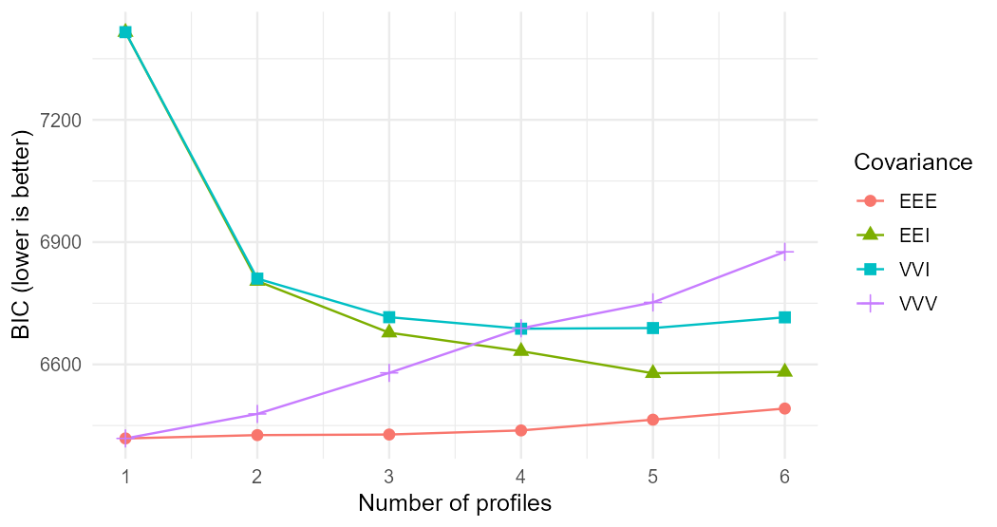
BIC by profile count and covariance structure
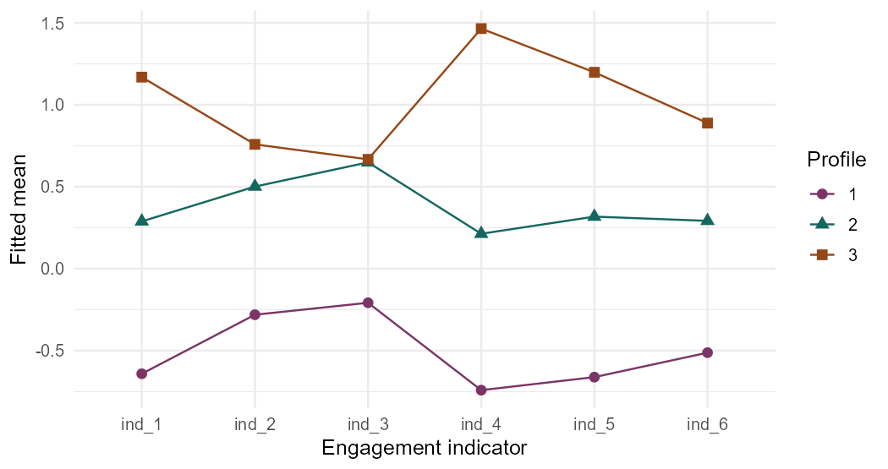
Three-profile VVV fitted means by engagement indicator

Distal outcome comparison
The demonstration fixes the three-profile VVV solution in advance and orders classes by their average indicator mean. The naive OLS estimates use modal classes and conventional standard errors. BCH inverts the posterior-estimated modal classification matrix and applies the resulting signed weights to class means. Its case bootstrap re-estimates that matrix with the indicator fit fixed. The resulting SE is conditional on that fit and excludes model selection uncertainty. The correction assumes modal assignment and persistence are independent within the true profile. Error is the estimate minus the generating contrast in this one simulation. Sampling and classification both contribute to the difference.
Contrast | Target | Modal OLS | OLS SE | OLS error
2 vs 1 | 0.65 | 0.46644843556 | 0.13262823771 | -0.18355156444
3 vs 1 | 1.35 | 0.93865078055 | 0.1214126777 | -0.41134921945

Corrected contrasts
Contrast | BCH estimate | Conditional SE | BCH error
2 vs 1 | 0.5725108129 | 0.18864748999 | -0.077489187103
3 vs 1 | 1.0512551835 | 0.13320325234 | -0.29874481646
Profiles describe patterns of indicators in an analysis sample. Causal mechanisms and discrete latent types require separate evidence.
Method reference Bakk and Vermunt (2016).

